Chapter 16, Solution 97.

A system is formed by cascading two systems as shown in Fig. 16.106. Given that the impulse responses of the systems are,

h₁(t) = 3e^{-t} u(t), h₂(t) = e^{-4t} u(t)

- Obtain the impulse response of the overall system.
- Check if the overall system is stable.

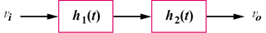

Figure 16.106
For Prob. 16.97.

Solution

- ,

,

- Since the poles of H(s) all lie in the left half s-plane, the system is stable.

